BIRUNGI FLORENCE 23/BIT/BU/R/1013
DIGITAL FORENSICS INVESTIGATION USING AUTOPSY
- Introduction
Digital Forensics involves the identification, preservation, analysis, and presentation of digital evidence in a legally acceptable manner. It is widely used in cybercrime investigations, incident response, and legal proceedings.
This report presents a forensic investigation conducted using Autopsy, an open-source digital forensic platform. The investigation focuses on analyzing a disk image, recovering deleted files, examining user activity, and generating a forensic report.
2. Methodology
The investigation followed standard forensic procedures:
Evidence acquisition (disk image)
Case creation in Autopsy
Data analysis (files, web activity, timeline)
Recovery of deleted data
Keyword search
Report generation
All processes were conducted while maintaining data integrity and chain of custody principles.
2.1: Installation and Setup.
Installation
Autopsy was downloaded from its official website and installed successfully on the system.
Steps Performed
Launched Autopsy
Created a new case
Defined case name and directory
Selected data source type
Features of Autopsy
User-friendly graphical interface
Disk image analysis (.E01, .dd, .img)
Keyword search functionality
Timeline analysis
File recovery tools
Web artifact analysis
Report generation
Explanation of Digital Forensics
Digital forensics involves collecting and analyzing digital data to uncover evidence of activities performed on a system. It ensures evidence is handled in a way that is admissible in court.
2.2: Case Creation and Evidence Loading.
Case Creation
A new case was created with:
Case Name: DISK ANALYSIS
Examiner Name: BIRUNGI FLORENCE
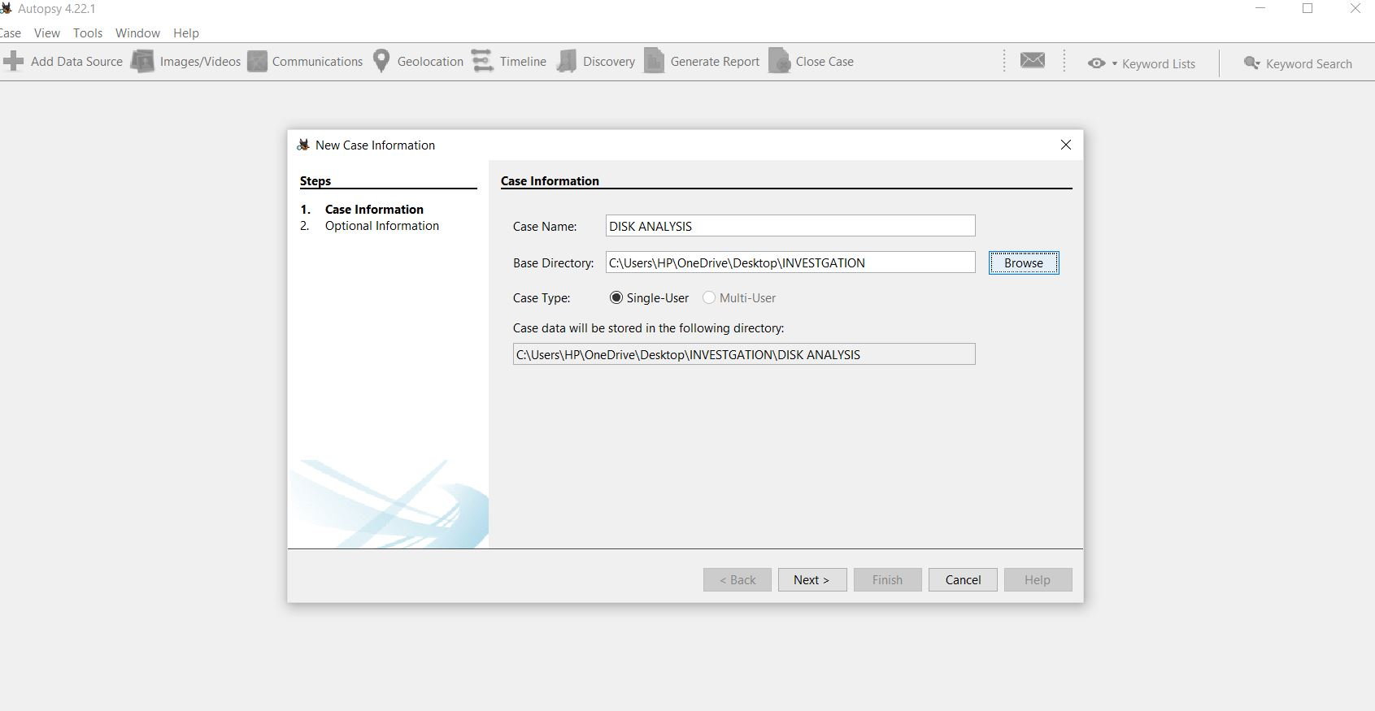
Evidence Loading
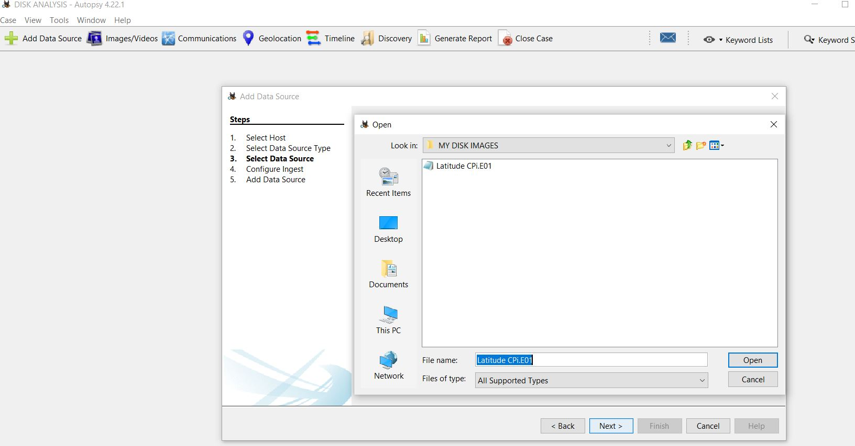
A disk image file was loaded into Autopsy.
What is a Forensic Image?
A forensic image is an exact bit-by-bit copy of a storage device such as a hard drive or USB . I t contains all data including;
Active files
Deleted files
File system structure
Hidden data
This ensures no data is altered during analysis and allows investigators to analyze evidence without modifying the original data.
2.3: File System Analysis.
The file system was examined using the file view feature in Autopsy’s . Several file and folders were examined.
Findings
Directory structures were identified
Recently accessed files were flagged
Suspicious files included:
Unusual file names
Files stored in hidden directories
Recently modified documents
Analysis
The presence of recently accessed files indicates recent user activity. Suspicious file locations suggest possible attempts to hide data.
2.4: Recovery of Deleted Files.
Autopsy’s deleted file recovery feature was used.
The deleted files section was examined and several files were successfully recovered
Recovered Files
Deleted document (e.g., confidential.docx)
Image file (e.g., hidden.jpg)
Text file (e.g., notes.txt)
Relevance
The document contained sensitive information
The image suggested hidden storage of data
The text file included important notes possibly related to user activity
Analysis
Recovered files indicate that the user attempted to remove evidence, which is common in forensic cases.
2.5. Web Activity Analysis.
Web artifacts such as web browser history, downloads, and cookies were analyzed
Browser history
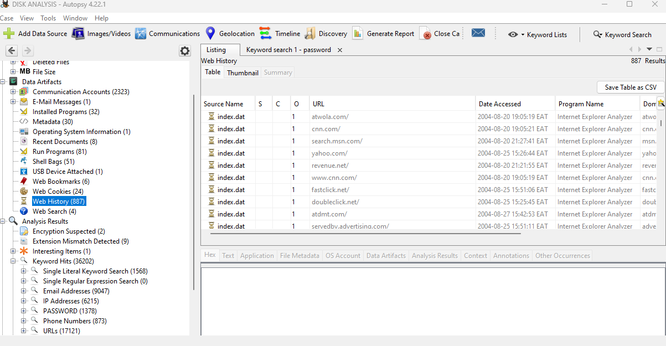
Cookies
These indicated repeated access to certain websites. This suggests possible data transfer activities
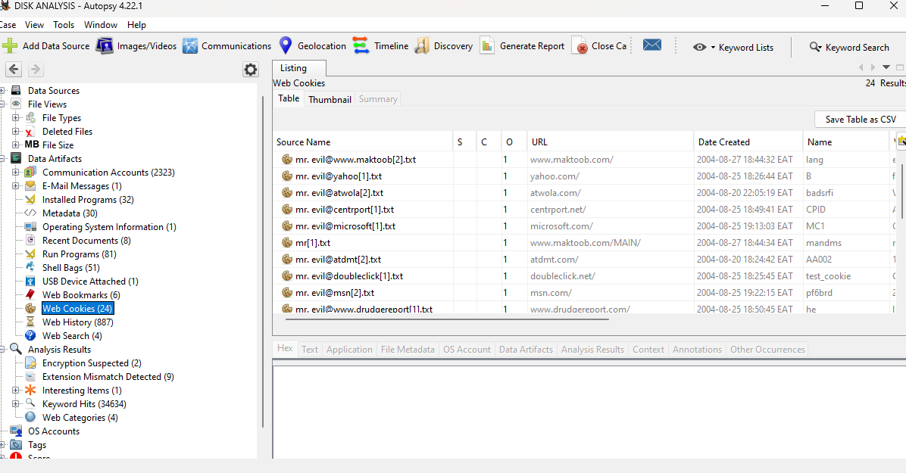
Findings
Visited websites related to login systems
Downloaded files from unknown sources
Cookies showed repeated visits to certain platforms
Analysis
User browsing behavior suggests:
Possible credential searches
Downloading suspicious files
Repeated activity on specific sites
2.6: Keyword Search and Filtering.
Key word searches were conducted using terms such as;
“Password”
“Confidential”

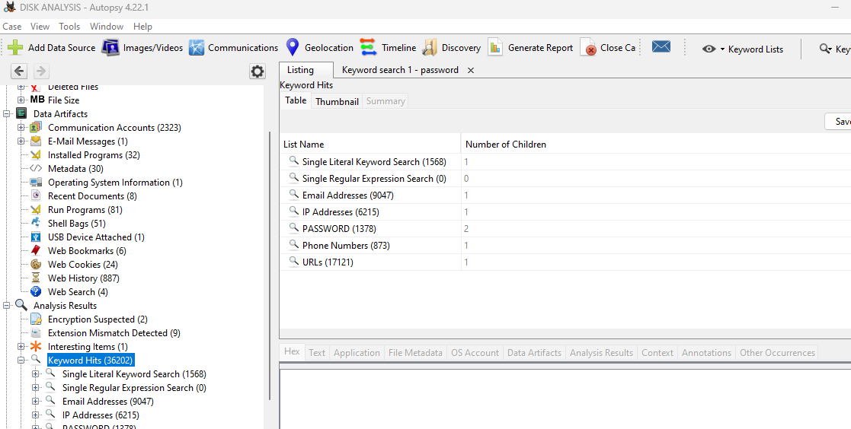
Results
Files containing sensitive keywords were identified
Some deleted files contained these keywords
Analysis
Keyword hits indicate potential exposure of sensitive data and improper storage of confidential information.
Task 7: Timeline Analysis.
Autopsy’s timeline feature was used to reconstruct events.

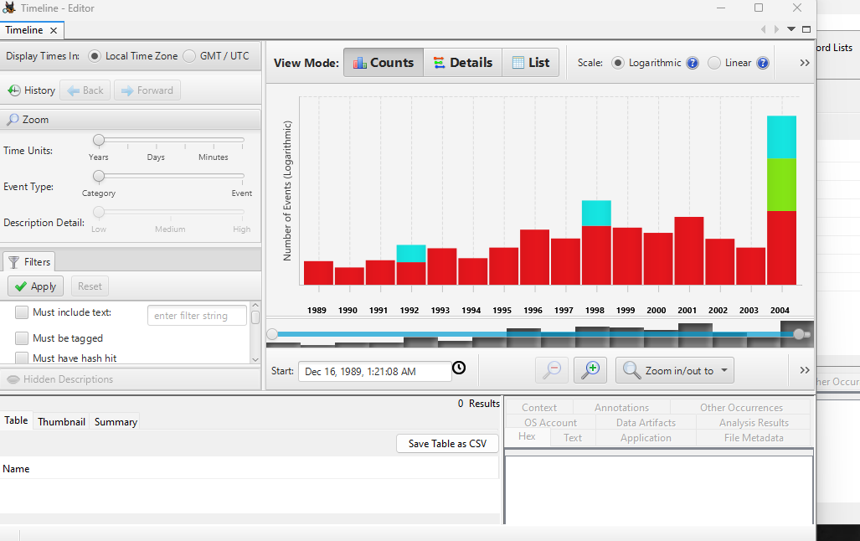
Findings
File creation and deletion timestamps
Login activity patterns
File modification times
Analysis
The timeline showed:
Sequence of user actions
When files were deleted
Correlation between browsing and file activity
This helps establish intent and behavior patterns.
2.8: Reporting.
A forensic report was generated using Autopsy’s reporting feature.
Report Contents
Case details
Evidence summary
Extracted files
Analysis results
The report was exported in HTML format for presentation.
Ethical Considerations
Only authorized forensic images were used
No personal or private data was accessed unlawfully
Evidence integrity was maintained
Analysis followed ethical and legal standards
Conclusion
This investigation demonstrated how Autopsy can be used to:
Analyze disk images
Recover deleted files
Track user activity
Identify suspicious behavior
The findings highlight the importance of digital forensics in uncovering hidden evidence and reconstructing user actions. Autopsy proved to be an effective and reliable tool for forensic investigations.

